S09- TextFromImage-base64-Home Assignment
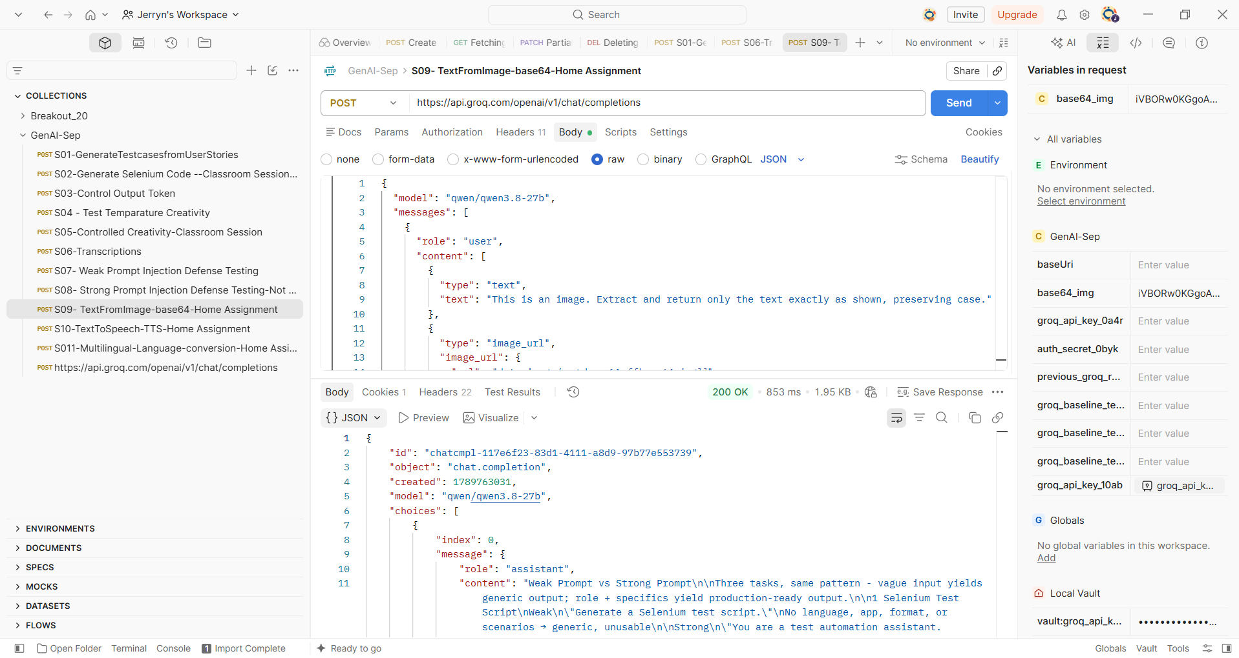
Output:
{
"id": "chatcmpl-117e6f23-83d1-4111-a8d9-97b77e553739",
"object": "chat.completion",
"created": 1789763031,
"model": "qwen/qwen3.8-27b",
"choices": [
{
"index": 0,
"message": {
"role": "assistant",
"content": "Weak Prompt vs Strong Prompt\n\nThree tasks, same pattern - vague input yields generic output; role + specifics yield production-ready output.\n\n1 Selenium Test Script\nWeak\n\"Generate a Selenium test script.\"\nNo language, app, format, or scenarios → generic, unusable\n\nStrong\n\"You are a test automation assistant. Generate a Selenium Java script to verify login on a Salesforce app. Include setup/teardown, explicit waits.\"\n✓ Persona + app + language + requirements → structured, production-ready\n\n2 Bug Report\nWeak\n\"Write a bug report.\"\nNo defect, severity, repro steps, or environment → vague, unusable\n\nStrong\n\"You are a QA engineer. Write a bug report for a checkout crash on Chrome after clicking 'Place Order' with an empty cart — severity, repro steps, expected vs actual.\"\n✓ Persona + defect + repro steps + structured fields · actionable\n\n3 API Test Cases\nWeak\n\"Generate API tests.\"\nNo endpoint, scenarios, framework, or expected results → incomplete\n\nStrong\n\"You are an API test automation assistant. Generate RL S1 Assured tests in Java for POSI /login — valid, invalid password, locked account — with expected status codes.\"\n✓ Persona + endpoint + scenarios + framework → production-ready"
},
"logprobs": null,
"finish_reason": "stop"
}
],
"usage": {
"queue_time": 0.129026807,
"prompt_tokens": 800,
"prompt_time": 0.056671772,
"completion_tokens": 261,
"completion_time": 0.493255798,
"total_tokens": 1061,
"total_time": 0.54992757
},
"usage_breakdown": null,
"system_fingerprint": "fp_424cb89518",
"x_groq": {
"id": "req_01m2v3140he71v1k82hmwcy0qz",
"seed": 608514319
},
"service_tier": "on_demand"
}

